**MS SQL SERVER**

**Standard Operating Procedures**

**(SOP)**

**Creation of DBA maintenance job**

Submitted to



**By**



CIS, Wipro Limited

Document Details

|  |  |
| --- | --- |
| Project Name | Innogy SE |
| Account | CIS |
| IT Component/Application Title | Creation of maintenance job |
| Current Version | 1.2 |
| List of Contributors | Pradipkumar Kansara, Kiran Bhalekar, Ayushi Gautam, Sivakumar Goud, Pramod Patil |
| Customer Contact Information |  |

Version History

(All revisions made to this document must be listed in chronological order. All revisions must be approved. Review and Approval can be done by an internal source or by the customer)

|  |  |  |  |  |  |
| --- | --- | --- | --- | --- | --- |
| Version | Date of Revision | Description | Author | Reviewed By | Approved By |
| 1.0 | 29-11-2017 | Initial Draft | Kiran Bhalekar | Pradipkumar Kansara | Santosh Badiger |
| 1.1 | **05-12-2017** | **Document Completed** | **Kiran Bhalekar** | **Pradipkumar Kansara** | **Santosh Badiger** |
| 1.2 | **10-11-2018** | **Updated the content** | **Pramod Patil** | **Pradipkumar Kansara** | **Santosh Badiger** |

Document Distribution List

|  |  |  |
| --- | --- | --- |
| **Sr.No** | **Name and Company** | **Purpose** |
| **1** | RWEIT-SQLDBA | **This document is about how to create DBA nightly maintenance job with all necessary steps** |

**TABLE OF CONTENT**

1. Purpose 4

2. Scope 4

3. Steps To create job 4

4. Reference 17

# 

# Purpose

This document is to cover how to create a DBA maintenance job in SQL server, which will help you to take backup of all databases and steps to maintain database consistency and durability

# Scope

This document is prepared for GSMC Wipro sustenance team and provides the concepts of maintenance job

# Steps to create DBA maintenance job

1. Login to SQL server

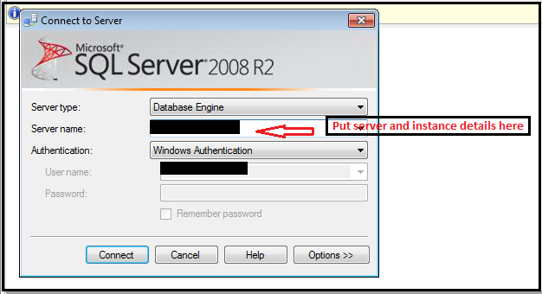

1. Click on connect, it will get connected as follows:

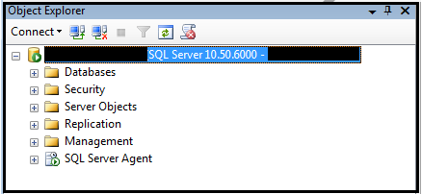

1. After successful connection, Expand ‘SQL server agent’ as follows:

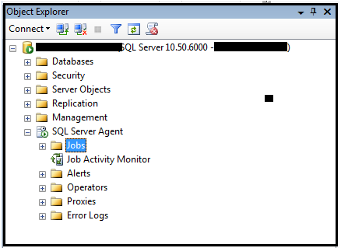

1. Right Click on ‘Jobs ’ and then click on ‘New job’

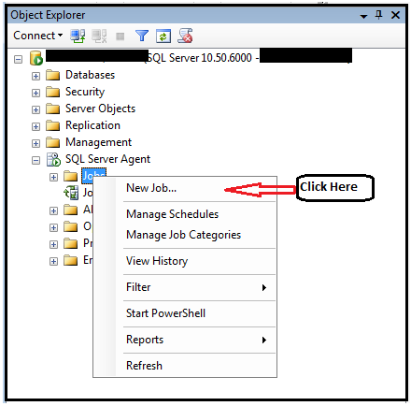

1. After clicking on ‘New job’, you will see below window:

Here you have to fill few details as mentioned in the screenshot:

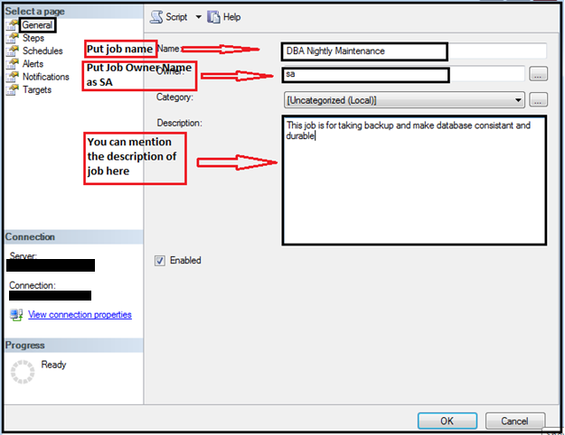

1. Once you fill all the details at ‘General’ window. Next step is to click on ‘Steps’. Once you click on ‘Steps’, you will find the next window as below. Here we have to create steps for DBA maintenance plan. Click on ‘New’ as shown in the screenshot to create step.

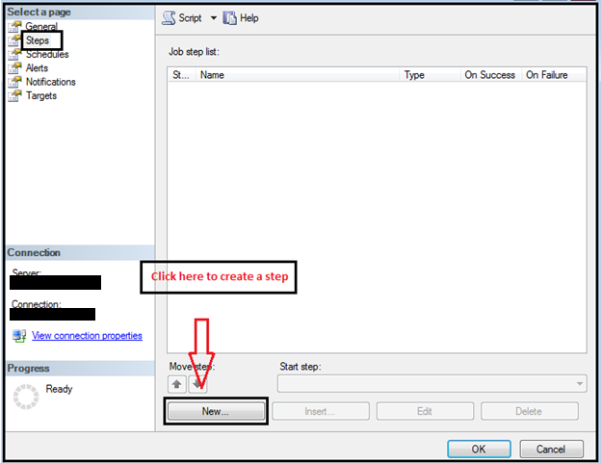

1. After clicking on ‘New’, you will be able to see the window as below:

Here, you have to mention the step name. As our DBA job starts with deletion of previous backup files of all databases, we will mention the stored procedure name as ‘sp_DBA_DeleteAllDatabasebackup’

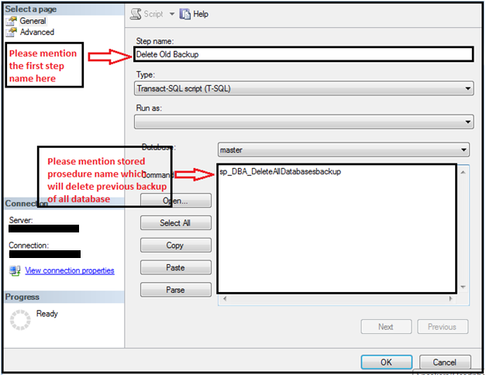

1. Now click on ‘advance’ tab which is at left hand side. Mention the actions as per the below screenshot.

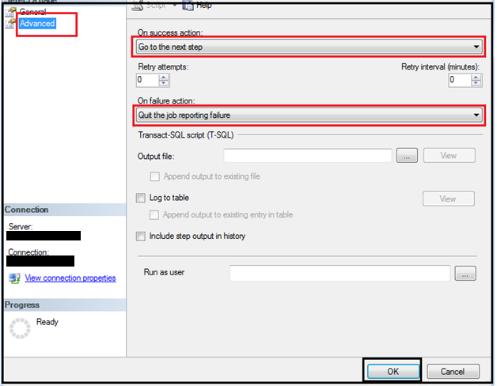

1. Now click on ‘OK’. You have successfully added first step. Now as per our standard process, we will 4 more steps as follows with same steps as the first one.
   1. Full backup
   2. Defragmentation
   3. Update stats
   4. DBCC
2. As per the below screenshot we will mention stored procedure name which we use while taking backup of all database as below

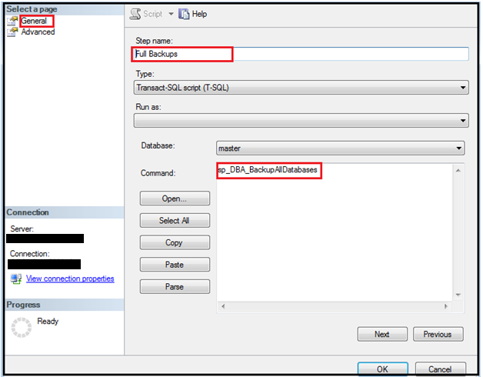

1. Here, we have to go to Advance option again and we have to mention same actions which we have specified in first step.
2. After selection of appropriate action in advance tab, click on ‘OK’. We will add our third step of ‘defragmentation’

Script : sp_msforeachdb "EXEC [?].dbo.sp_DBA_Defrag 10,50,1000, @RecordResults=0"

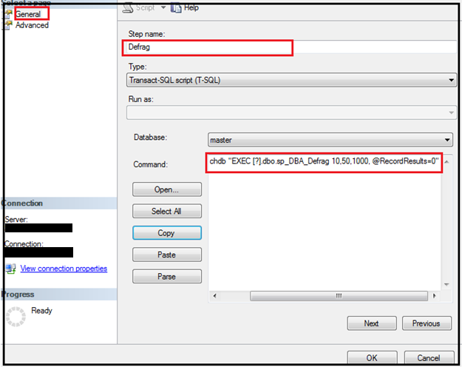

1. Here, we have to go to Advance option again and we have to mention same actions which we have specified in first step.
2. After selection of appropriate action in advance tab, click on ‘OK’. We will add our fourth step of ‘Update Stats’

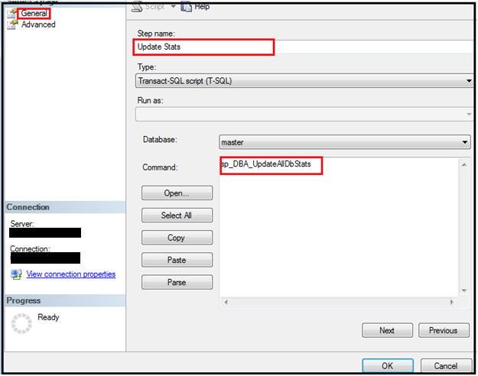

1. Here, we have to go to Advance option again and we have to mention same actions which we have specified in first step.
2. We will add our last step of ‘DBCC’ as below:

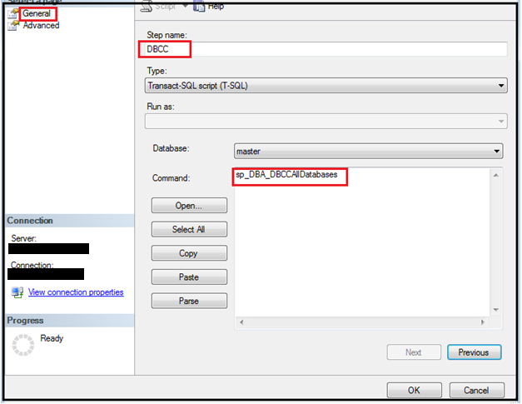

1. As this is our last step in this job, we have to appropriate settings in advance option as below:

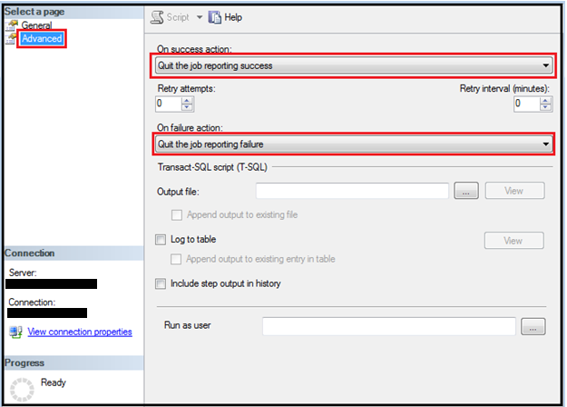

1. Now, your nightly maintenance job has been successfully created.
2. We have to create schedule for this job. We will follow following steps now:
   1. First click on schedule which is at left hand side of dilog box and then click on NEW to create schedule.

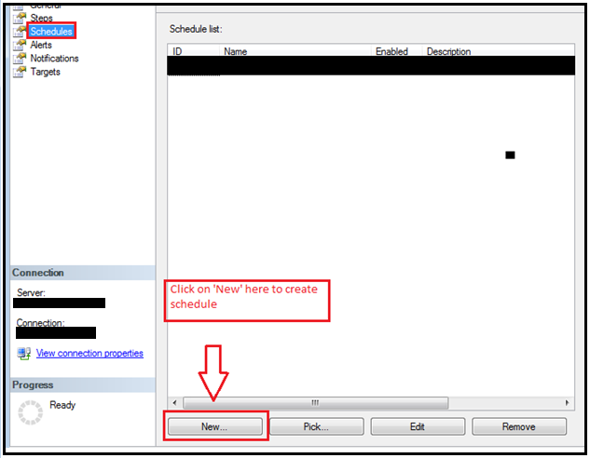

1. Once you click on ‘New’, you will see below window and then please update details as per your requirement and click on OK

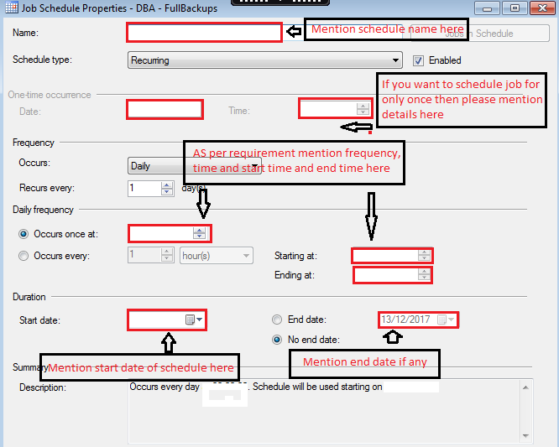

1. Again click on ‘OK’ and your nightly maintenance job is created now as per your requirement.